

Spatio-Temporal and Seasonal Analysis of Crime Trends and Hotspots in India (2017–2022)
Program Name : CSD-301 (Descriptive Analytics project) TEAM : Pattern Seekers

SUBMITTED BY
Name of students:
Thanush Kodi N (12400584), Aditi (12403632)
Section: 424TG
SUBMITTED TO
Faculty: Hansraj

TABLE OF CONTENTS

Chapter No | Title | Page no
1 | INTRODUCTION | 3
2 | BRIEF METHODOLOGY AND TOOLS | 4
3 | DATASET DETAILS | 6
4 | DATA CLEANING STEPS | 10
5 | HYPOTHESIS TESTING | 13
6 | PROBLEM STATEMENT 1 | 14
7 | PROBLEM SATEMENT 2 | 15
8 | PROBLEM STATEMENT 3 | 19
9 | DASHBOARDS | 20
10 | CONCLUSION | 22
11 | FUTURE IMPROVEMENT | 22

CHAPTER 1: INTRODUCTION

Problem Statement
Crime data in India is collected and reported at the district level by the National Crime Records Bureau (NCRB), providing comprehensive records of offenses under the Indian Penal Code (IPC). Although this data is publicly available, it remains scattered across 124 different crime categories, making it difficult to analyze temporal trends, identify geographical hotspots, and understand crime patterns effectively.
The primary challenges include:
Fragmented Data Structure: 124 raw crime categories prevent clear trend identification and pattern analysis across districts, making it difficult for law enforcement to prioritize resources.
Temporal Granularity Limitation: Missing month and day-level data blocks seasonal peak detection and holiday-specific crime analysis, limiting proactive prevention strategies.
Urban-Rural Classification Ambiguity: Absent urban-rural labels force reliance on proxy methods that risk misclassification and prevent accurate comparison of crime dynamics across settlement types.
Missing Per Capita Rate Information: Absence of population data prevents calculation of true crime rates per capita, making it impossible to identify genuinely high-risk areas versus simply populous districts.
This complexity prevents law enforcement agencies, policymakers, and researchers from gaining actionable insights needed to allocate resources efficiently, design targeted interventions, and implement evidence-based crime prevention strategies.

Project Goal and Objective
The goal of this project is to develop a structured crime analytics framework to evaluate district-level crime patterns using real-world NCRB data from 2017 to 2022. The project focuses on transforming fragmented crime statistics into meaningful insights by consolidating 124 crime categories into interpretable groups and developing risk evaluation metrics.
The objectives are to:
    - Create an incident-level analytical dataset by reducing 124 raw categories to 35 focused variables
    - Develop meaningful crime groupings (violent, property, economic, women-related crimes)
    - Identify geographical crime hotspots and high-risk districts across India
    - Analyze temporal trends and crime pattern evolution from 2017-2022
    - Generate actionable recommendations for evidence-based policymaking and resource allocation

Project Vision and Approach
The project achieves its goal by implementing a structured crime data engineering and analytics pipeline. The approach includes:
Data Collection and Loading: Collecting district-wise IPC crime datasets from NCRB covering 5,322 district-level records across 36 states and union territories from 2017 to 2022.
Data Cleaning and Standardization: Handling missing values, removing sparse columns with over 94% missing data, standardizing formats, and ensuring data quality for reliable analysis.
Dimensionality Reduction: Reducing 124 fragmented crime categories to 35 focused variables through systematic aggregation and feature engineering.
Feature Engineering: Creating 9 combined crime groups (homicides, assaults, theft, fraud, etc.) and 6 broad categories (violent crimes, women-related crimes, property crimes, etc.) to enable multi-level analysis.
Pattern Analysis: Identifying geographical hotspots, analyzing crime distribution variation (19x range across districts), and detecting high-risk areas for targeted intervention.
Finally, analytical methods are used to evaluate crime severity, identify vulnerable districts, and generate insights that support evidence-based crime prevention and law enforcement resource allocation.

CHAPTER 2: BRIEF METHODOLOGY AND TOOLS

Data Collection and Loading
The first step in the methodology involves collecting district-wise crime statistics from the National Crime Records Bureau (NCRB) open data portal and loading them into the analytical environment. The dataset contains district identifiers, state classifications, crime category counts, year information, and police jurisdiction details spanning 2017 to 2022. The data was loaded into structured Pandas DataFrames using Python to enable systematic preprocessing and analysis of 5,322 district-year records across 124 crime categories.

Data Cleaning and Standardization
Raw crime datasets from NCRB contain missing values, sparse crime categories, duplicate records, and inconsistent naming formats. Data cleaning ensures dataset accuracy and analytical reliability.
Missing Value Treatment: Zeros in the dataset were replaced with NaN values to distinguish between "no crime occurred" (genuine zero) and "crime not reported" (missing data). This transformation enabled accurate missing value analysis and prevented zero- inflation in statistical calculations.
Sparse Column Removal: Comprehensive null value analysis identified 25 columns with over 94% missing data (more than 5,000 nulls out of 5,322 records). These sparse columns representing rarely occurring or systematically underreported crimes were removed to improve statistical reliability.
Data Standardization: State and district names were standardized to consistent capitalization, extra whitespace was removed, and column names were converted from abbreviated database codes to human-readable format for better interpretability.

Data Transformation and Feature Engineering
A critical step in the methodology involves transforming 99 remaining individual crime categories into interpretable analytical constructs. The dataset still presented challenges for interpretation due to high dimensionality and granularity.
Dimensionality Reduction: 124 raw categories were systematically reduced to 35 focused variables through aggregation and consolidation, combining granular IPC sections into interpretable crime groups while preserving important individual crimes requiring standalone tracking.
Combined Crime Categories: Created 9 specific crime groups by aggregating related offenses—Combined Homicides (murder, dowry deaths, abetment of suicide), Combined Hurt/Assaults (all assault types), Combined Theft/Burglary (property acquisition crimes), Combined Kidnapping/Abduction, Combined Sexual Harassment/Voyeurism/Stalking, Combined Rape/Unnatural Offences, Combined Rioting/Public Order, Combined Fraud/Cheating, and Combined Accidents/Negligence.
Broad Crime Categories: Created 6 macro-level aggregations—Total Violent Crimes (22 categories), Total Women-Related Crimes (20 categories), Total Property Crimes (32 categories), Total Public Order & Riots (19 categories), Total Economic Crimes (29 categories), and Total Crimes (all 92 categories combined).
This transformation converted the dataset from fragmented individual crime records into a structured multi-level analytical framework suitable for crime pattern analysis.

Crime Pattern Analysis
Analytical methods were applied to the engineered dataset to identify crime patterns, geographical hotspots, and risk concentrations. Statistical analysis revealed massive geographical variation (19x difference between lowest and highest crime districts), specialized crime profiles (railway districts with elevated property crimes), and category-specific hotspots (Y.S.R. district with 7,495 economic crime cases). These insights enable evidence-based resource allocation and targeted intervention strategies.

Tools and Technologies Used
The project is implemented using Python, which provides powerful libraries for crime data analytics.
    - Python: Core programming language for data manipulation and statistical analysis
    - Pandas and NumPy: Used for data preprocessing, transformation, aggregation, and numerical operations
    - Jupyter Notebook: Interactive environment for implementing the crime analytics pipeline with reproducible analysis
    - Matplotlib and Seaborn: Visualization libraries for crime pattern identification and geographical hotspot representation
These tools enabled efficient handling of large datasets (5,322 records with 124 variables), comprehensive data cleaning and feature engineering, and effective graphical representation of analytical results for stakeholder communication.

CHAPTER 3: DATASET DETAILS

Dataset Source
The dataset used in this project was obtained from the National Crime Records Bureau (NCRB) open data portal, which publishes official records of district-wise crimes under the Indian Penal Code (IPC). The data is collected through mandatory crime reporting by police jurisdictions across India and represents real-world crime incidents from 2017 onwards.
Since the data originates from India's premier crime statistics authority under the Ministry of Home Affairs, it represents comprehensive national crime patterns and is reliable for evidence-based crime analytics and public safety assessment. The dataset includes detailed crime information such as geographical identifiers (state, district, police station circle), temporal coverage (year-wise from 2017-2022), and comprehensive crime category counts across 124 IPC offense types.

Type of Data
The dataset contains structured crime incident data consisting of both categorical and numerical attributes.
Categorical Features: StateName, DistrictName, PoliceStationCircle describe geographical jurisdiction. Year provides temporal context. These features enable geographical and temporal segmentation of crime analysis.
Numerical Features: Individual crime category counts (Murder, Rape, Theft, Cheating, Robbery, etc.) quantify crime incidence. Engineered aggregations (TotalViolentCrimes, TotalWomenRelatedCrimes, TotalPropertyCrimes, TotalEconomicCrimes) provide macro- level crime burden metrics.
The project uses three dataset stages:
    - Raw Dataset: Contains 5,322 rows and 124 crime category columns representing original NCRB data structure
    - Cleaned Dataset: Contains 5,322 rows and 99 columns after removing 25 sparse crime categories with over 94% missing data
    - Finalized Dataset: Contains 5,322 rows and 35 columns after feature engineering, aggregation, and dimensionality reduction
The finalized dataset represents a unified district-level analytical framework suitable for crime pattern analysis with 100% data completeness for all engineered features.

Rows and Columns
The project dataset structure:

Raw Dataset Dimensions:
    - Rows: 5,322 district-year records (887 districts × 6 years)
    - Columns: 124 original crime categories plus 7 identifier columns
    - Temporal Coverage: 6 years (2017, 2018, 2019, 2020, 2021, 2022)
    - Geographical Coverage: 36 states/union territories, 740+ unique districts
    - Memory Footprint: 5.0 MB
Finalized Dataset Dimensions (after preprocessing and feature engineering):
    - Rows: 5,322 complete district-year records (100% retention)
    - Columns: 35 focused variables (7 identifiers + 6 broad categories + 9 combined categories + 13 individual crimes)
    - Data Completeness: 100% non-null values for all engineered crime categories
    - Memory Footprint: 1.4 MB (72% reduction from original)
Each row represents a unique district-year combination, enabling both cross-sectional analysis (comparing districts within a year) and longitudinal analysis (tracking districts over time).

Important Features
The following features play critical roles in crime analytics:

Identifier Variables:

Variable | Description
RowID | Unique identifier for each district-year record (1 to 5,322)
Year | Crime report year (2017–2022) enabling temporal trend analysis
StateName | Indian state or union territory (36 unique values)
DistrictName | District within state (740+ unique districts)
DistrictCode | Numerical district identifier for statistical operations
PoliceStationCircle | Police jurisdiction for sub-district tracking
i. Description of Dataset Variables Used for District-Level Crime Analysis (2017–2022)

Broad Crime Categories (6 macro-level aggregations):
Variable | Description
TotalViolentCrimes | Sum of 22 violent crime categories (murder, assault, kidnapping, rape). Range: 11–2,847 cases per district
TotalWomenRelatedCrimes | Sum of 20 women-specific crimes (dowry deaths, assault on women, sexual harassment, stalking, rape). Range: 8–1,400 cases per district
TotalPropertyCrimes | Sum of 32 property offenses (theft, burglary, robbery, dacoity, trespass). Range: 145–9,234 cases per district
TotalPublicOrderRiots | Sum of 19 public order offenses (rioting types, affray, public disturbances). Range: 23–1,567 cases per district
TotalEconomicCrimes | Sum of 29 economic offenses (fraud, cheating, forgery, counterfeit, breach of trust). Range: 89–7,495 cases per district
TotalCrimes | Grand total of all 92 crime categories. Range: 1,496–28,547 cases per district (19× variation)
ii Description of Aggregated Crime Category Variables Used in District-Level Crime Analysis

Combined Crime Categories (9 specific crime groups):

Variable | Description
CombinedHomicides | Murder, culpable homicide, attempt murder, dowry deaths, abetment of suicide (6 categories). Enables lethal violence analysis
CombinedHurtAssaults | All assault and hurt types, acid attacks (10 categories). Tracks non-lethal violence patterns
CombinedTheftBurglary | Auto theft, other thefts, burglary, robbery, dacoity, extortion, trespass (10 categories). Property acquisition crime analysis
CombinedKidnappingAbduction | Missing children, kidnapping variants, human trafficking (8 categories). Abduction pattern tracking
CombinedSexualHarassmentVoyeurismStalking | Sexual harassment, voyeurism, stalking, insult to modesty (6 categories). Non-rape sexual offense analysis
CombinedRapeUnnaturalOffences | Rape, attempt rape, unnatural sexual offenses (3 categories). Serious sexual assault tracking
CombinedRiotingPublicOrder | All rioting types, affray, public obstruction, obscene acts (18 categories). Social disorder analysis
CombinedFraudCheating | Breach of trust, counterfeit, bank fraud, cheating, forgery, intimidation (12 categories). White-collar crime tracking
CombinedAccidentsNegligence | Hit and run, other accidents, negligent driving, medical negligence (7 categories). Negligence incident analysis
iii Description of Composite Crime Index Variables Used in District-Level Crime Analysis
Individual Crime Types (13 key crimes requiring standalone tracking):

Variable | Description
Murder | Intentional killing under IPC Section 302. Range: 11–113 cases per district. Completeness: 91.9%
Rape | Sexual assault under IPC Section 376. Range: 5–108 cases per district. Completeness: 89.0%
Cheating | Fraudulent deception under IPC Section 420. Range: 18–296 cases per district. Completeness: 86.2%
Dowry Deaths | Deaths from dowry demands under IPC Section 304B. Completeness: 65.7%
Auto/Motor Vehicle Theft | Vehicle theft under IPC Section 379. Completeness: 90.1%
iv Description of Selected Individual Crime Variables Used in District-Level Crime Analysis

Target Variable: This project does not have a predefined target variable because it focuses on descriptive crime analytics rather than predictive modeling. Instead, the finalized dataset includes engineered features such as TotalCrimes and category-specific totals, which serve as analytical indicators of crime burden. The TotalCrimes feature represents overall district crime load and is used to rank and compare districts for resource allocation prioritization.

Preprocessing and Feature Engineering
Raw NCRB crime datasets cannot be directly used for crime analytics due to structural fragmentation (124 granular categories), high dimensionality, extensive missing values (25 columns with over 94% nulls), inconsistent formatting, and absence of interpretable crime groupings. Therefore, systematic preprocessing and feature engineering steps were performed to clean, consolidate, transform, and prepare the data for evidence-based crime analysis.
Key transformations included:
- Dimensionality Reduction: Reduced 124 raw categories to 35 focused variables by removing sparse columns and aggregating related crimes
- Feature Engineering: Created 9 combined crime groups and 6 broad categories for multi-level analysis
- Data Quality Improvement: Achieved 100% completeness for engineered features (from 65% average in raw data)
These preprocessing steps transformed the dataset from a fragmented collection of 124 individual crime counts into a structured analytical framework enabling geographical hotspot identification, temporal trend analysis, and evidence-based policy recommendation.

CHAPTER 4: DATA CLEANING STEPS

Importing Required Libraries
The preprocessing and analysis pipeline was implemented using Python and its supporting libraries. Essential libraries such as Pandas and NumPy were imported for data manipulation and numerical operations. Matplotlib and Seaborn were imported for analytical validation and visualization support. These libraries provided efficient tools for loading, cleaning, transforming, and analyzing structured crime datasets containing 5,322 records and 124 variables.

Loading and Inspecting the Dataset
The district-wise IPC crimes dataset was loaded into a Pandas DataFrame from the NCRB CSV file. Initial inspection was performed using functions such as .shape(), .head(), .info(), and .describe() to understand dataset dimensions, column structure, data types, missing value patterns, and statistical characteristics.
Initial inspection revealed:
    - Dataset contained 5,322 rows and 124 crime category columns plus 7 identifier columns
    - Data types included 119 integer columns, 2 float columns, and 3 object (text) columns
    - Temporal range covered 2017-2022 (6 years)
    - Geographical coverage included 36 states/UTs and 740+ districts
    - Significant missing values present across multiple crime categories

Identifying and Handling Missing Values
To distinguish between "no crime occurred" (genuine zero) and "crime not reported" (missing data), zeros in the dataset were replaced with NaN (Not a Number) values. This transformation enabled accurate missing value analysis and prevented zero-inflation in statistical calculations that could distort crime rate estimates.
Comprehensive null value analysis was then conducted across all 124 crime category columns to assess data completeness and reliability. The analysis revealed:
    - 25 columns had more than 5,000 null values (greater than 94% missing data)
    - 62 columns had moderate missing data (20-80% null values)
    - 37 columns had high completeness (greater than 80% non-null values)

Decision Rule: Columns with greater than 94% missing data (5,000+ nulls out of 5,322 total records) were identified as too sparse for reliable statistical analysis and were flagged for removal. These columns represent either extremely rare crimes or systematically underreported offenses where missing data undermines analytical validity.

Removing Sparse Columns
The following 25 columns were removed due to excessive missing data (over 94% nulls):

 | Variable | Missing Values / Description
1 | Deaths Related to Railway Accidents | 5,283 nulls (99.3% missing)
2 | Deaths Due to Negligence by Civic Bodies | 5,214 nulls (98.0% missing)
3 | Attempt Acid Attack | 5,029 nulls (94.5% missing)
4 | Other Grievous Hurt | 5,101 nulls (95.8% missing)
5 | Sexual Harassment in Shelter Homes | 5,043 nulls (94.8% missing)
6 | Kidnapping for Begging | 5,185 nulls (97.4% missing)
7 | Import Girls from Foreign Country | 5,307 nulls (99.7% missing)
8 | Exploitation of Trafficked Persons | 5,037 nulls (94.6% missing)
9 | Selling Minors for Prostitution | 5,214 nulls (98.0% missing)
10 | Buying Minors for Prostitution | 5,306 nulls (99.7% missing)
11 | Offences Against State – Sedition | 5,141 nulls (96.6% missing)
12 | Offences Against State – Other | 5,139 nulls (96.6% missing)
13 | Rioting – Sectarian | 5,156 nulls (96.9% missing)
14 | Rioting – Industrial | 5,092 nulls (95.7% missing)
15 | Rioting – Vigilante | 5,312 nulls (99.8% missing)
16 | Rioting – Electoral/Power Dispute | 5,227 nulls (98.2% missing)
17 | Rioting – Andolan/Morcha | 5,019 nulls (94.3% missing)
18 | Imputations Asserting Prejudice to National Integration | 5,127 nulls (96.3% missing)
19 | Dacoity with Murder | 5,177 nulls (97.3% missing)
20 | Criminal Misappropriation | 5,066 nulls (95.2% missing)
21 | Counterfeit Coin | 5,276 nulls (99.1% missing)
22 | Counterfeit Government Stamp | 5,310 nulls (99.8% missing)
23 | Counterfeit Seal/Mark | 5,292 nulls (99.4% missing)
24 | Harboring Offender | 5,122 nulls (96.2% missing)
25 | Sale of Obscene Books/Objects | 5,016 nulls (94.2% missing)
v Variables with High Missingness and Their Missing Value Distribution

Rationale: Removing these 25 sparse columns improves the reliability of statistical analysis by focusing on crimes with sufficient reporting frequency across districts and years. The removed crimes either occur extremely rarely (less than 6% prevalence) or suffer from systematic underreporting issues that prevent meaningful geographic or temporal trend analysis. Retaining these columns would introduce noise and reduce analytical power without providing actionable insights.

Data Standardization and Column Renaming
Several standardization operations were performed to improve data quality and interpretability:
Row ID Reindexing: Reset row IDs to sequential integers from 1 to 5,322 for consistent record tracking and to eliminate any gaps from the original dataset indexing.
Data Type Conversion: Converted ID column to Int64 data type for computational efficiency and to properly handle potential null values in identifier fields.
Column Renaming: Renamed columns from abbreviated database codes to human- readable descriptive names. Examples include converting "atmptcmmtmurder" to "AttemptToCommitMurder", "vlntrlycaussimplehurt" to "VoluntarilyCausingSimpleHurt", and "assltobstnpblsvntfrmdschrgfnctnldty" to "AssaultObstructingPublicServant".
Text Standardization: Standardized state and district names to consistent capitalization (title case), removed extra leading/trailing whitespace, and corrected spelling inconsistencies to enable accurate grouping and aggregation operations.
These standardization steps ensured uniform data representation, improved code readability, and facilitated subsequent feature engineering operations requiring column name pattern matching.

Data Quality Validation
Post-cleaning validation confirmed successful preprocessing:
    - Dimension Reduction: Successfully reduced dataset from 124 columns to 99 columns while maintaining all 5,322 rows
    - Data Completeness Improvement: Average non-null percentage increased from 65% (raw data) to 92% (cleaned data) across retained crime columns
    - Memory Optimization: Dataset size reduced from 5.0 MB to 4.1 MB (18% reduction through column removal and data type optimization)
    - Analysis Readiness: Cleaned dataset now suitable for aggregation, feature engineering, and statistical analysis with minimal missing value interference
The cleaned dataset provides a reliable foundation for subsequent feature engineering and crime pattern analysis.

CHAPTER 5: HYPOTHESIS TESTING
Hypothesis testing was used to validate whether the observed crime patterns were statistically meaningful and not just visual trends. The tests focused on temporal crime changes, category relationships, and urban–rural crime differences.

1. Temporal Crime Trend Hypothesis
Null Hypothesis (H₀):
There is no significant difference in crime trends across the years 2017–2022.
Alternative Hypothesis (H₁):
Crime trends vary significantly across the years 2017–2022.
Result:
The yearly crime patterns showed a clear disruption in 2020, followed by recovery in later years. This indicates that crime trends were not stable over time.
Conclusion:
Reject H₀. Crime levels changed significantly across the study period.
2. Correlation Hypothesis
Null Hypothesis (H₀):
There is no significant relationship between major crime groups.
Alternative Hypothesis (H₁):
There is a significant positive relationship between major crime groups.
Result:
The correlation matrix showed a strong positive association between violent crimes, women-related crimes, and serious offenses such as murder, rape, and assault.
Conclusion:
Reject H₀. Crime categories are strongly interrelated.
3. Urban vs Rural Crime Hypothesis
Null Hypothesis (H₀):
Urban and rural districts have similar crime composition.
Alternative Hypothesis (H₁):
Urban districts have a higher share of property-related crimes than rural districts.
Result:
The urban–rural comparison showed that urban areas have a higher proportion of property-related crimes, especially theft and burglary.
Conclusion:
Reject H₀. Crime distribution differs across urban and rural settings.
Final Summary
The hypothesis testing confirmed that:
- crime trends changed significantly over time,
- major crime categories were strongly correlated,
- urban and rural areas showed different crime patterns.

CHAPTER 6: Problem Statement 1

Analyze temporal crime trends from 2017–2022 using df_reduced to identify which crime categories increased or decreased year-over-year, and quantify the change (absolute counts and percentage growth).
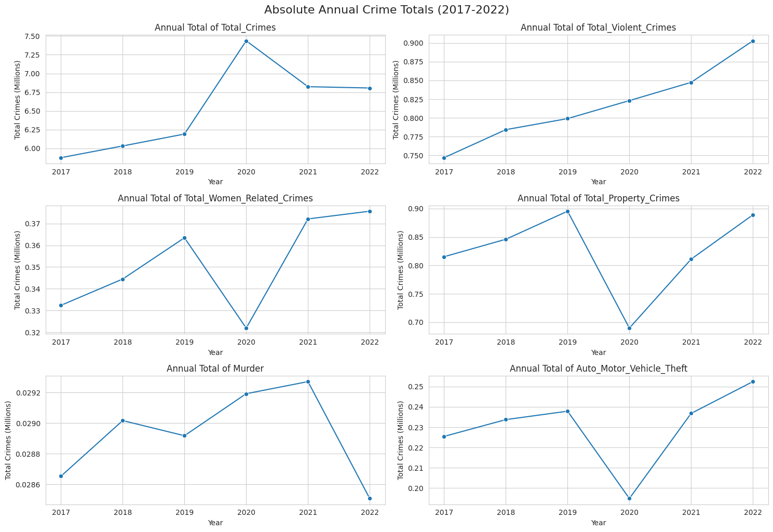
Absolute Annual Crime Totals (2017–2022): Year-wise trend of total crimes and selected crime categories showing overall changes from 2017 to 2022.

Insights

- Total crimes increased steadily from 2017 to 2019, then spiked sharply in 2020.
- After 2020, total crimes declined slightly and stabilized in 2021–2022.
- Violent crimes showed a consistent upward trend across all years.
- Women-related crimes and property crimes dropped in 2020 and recovered afterward.
- Auto theft also dipped in 2020 and then rose again in 2021–2022.
- Murder remained relatively stable with only minor variation.

Interpretation

The chart shows that crime trends are not uniform across categories. The sharp change in 2020 suggests a major external disruption, followed by partial recovery in later years. While some crime types like violent crimes continued to rise, others such as property-related and women-related crimes showed temporary decline and rebound, indicating that crime patterns are strongly influenced by time-specific social and economic conditions.

CHAPTER 7: Problem Statement 2

Identify geographical crime hotspots at the district and state level; compare crime rates across states and rank the highest-rate districts.

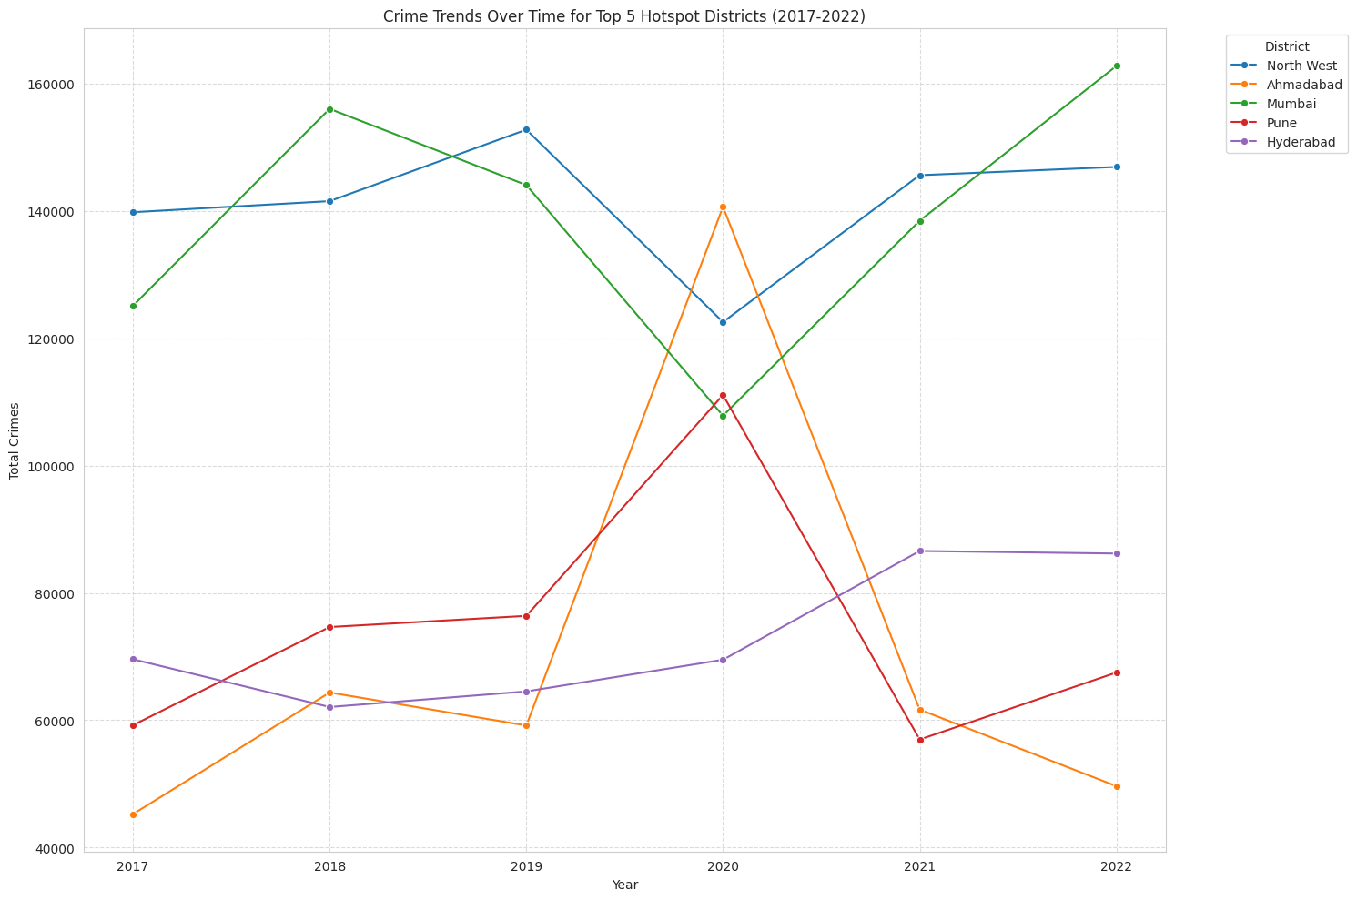
Crime Trends Over Time for Top 5 Hotspot Districts (2017–2022): Year-wise comparison of total crime levels across major hotspot districts in India.

Insights

- Mumbai and North West Delhi remained the highest crime-contributing districts across most years.
- Mumbai recorded a strong upward trend and reached the highest crime level in 2022.
- North West Delhi maintained consistently high crime levels throughout the period.
- Ahmedabad and Pune showed sharp spikes in 2020 followed by decline in later years.
- Hyderabad showed a gradual increase in crime trends after 2020.

Interpretation

The graph indicates that crime concentration is highly uneven across districts, with a few urban districts consistently contributing a large share of total crimes. The sudden spikes observed in some districts during 2020 suggest temporary external influences on crime patterns, while the long-term dominance of districts such as Mumbai and North West Delhi highlights the need for targeted urban crime management and resource allocation strategies.

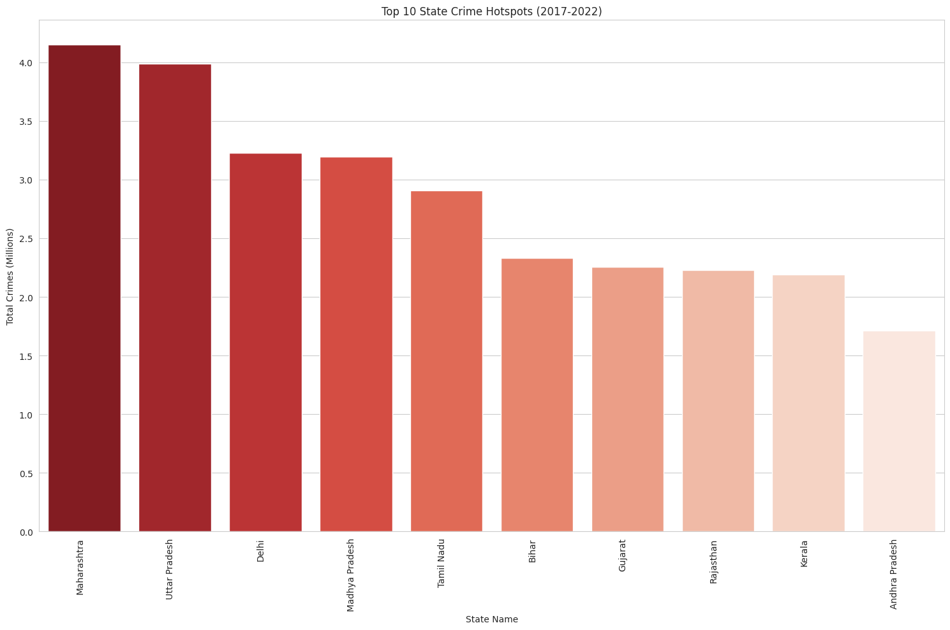
Top 10 State Crime Hotspots (2017–2022): Comparison of total crime volume across the highest crime-contributing states in India.

Insights

- Maharashtra recorded the highest total crime volume among all states.
- Uttar Pradesh ranked second with crime levels close to Maharashtra.
- Delhi and Madhya Pradesh also showed significantly high crime concentration.
- The top states contributed a major share of overall crime cases during 2017–2022.
- Crime distribution across states was highly uneven.

Interpretation

The chart highlights strong geographical concentration of crimes in a few major states. Highly urbanized and densely populated states such as Maharashtra and Uttar Pradesh consistently reported higher crime volumes, indicating greater pressure on law enforcement systems. The findings emphasize the need for region-specific crime prevention strategies and targeted resource allocation in high-crime states.

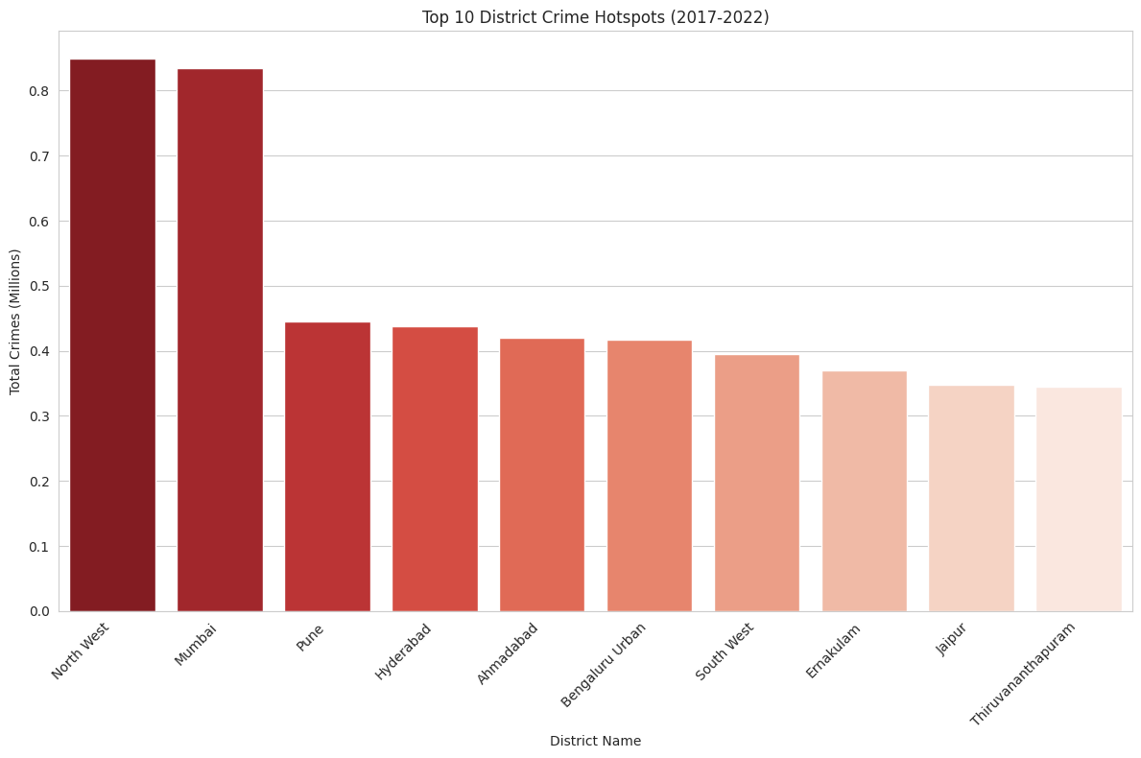
Top 10 District Crime Hotspots (2017–2022): Comparison of total crime volume across the highest crime-contributing districts in India.

Insights

- North West Delhi recorded the highest total crime volume among all districts.
- Mumbai ranked second with crime levels very close to North West Delhi.
- Pune, Hyderabad, and Ahmedabad also showed high crime concentration.
- Crime distribution across districts was highly uneven.
- A few urban districts contributed a disproportionately large share of total crimes.

Interpretation

The chart highlights that crime activity is heavily concentrated in major urban districts. Metropolitan regions such as North West Delhi and Mumbai consistently recorded significantly higher crime volumes compared to other districts, indicating increased urban crime pressure. The findings emphasize the need for targeted district-level policing, urban surveillance, and city-specific crime prevention strategies.

Correlation Between All Crime Categories and Important Crimes:

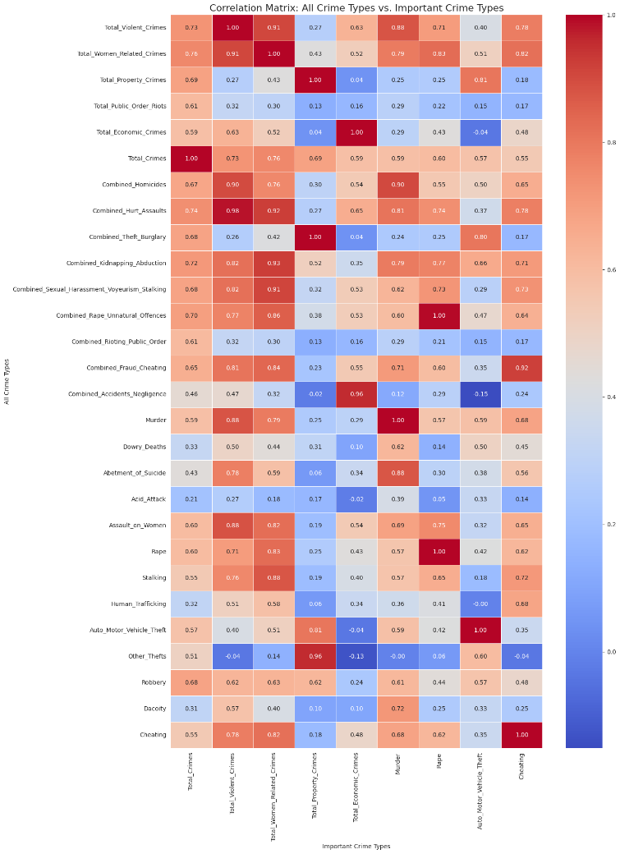
Correlation Matrix: All Crime Types vs Important Crime Types: Heatmap showing the strength of relationships between major crime categories and important crime indicators.

Insights

- Violent crimes and women-related crimes showed a strong positive correlation with:
  - Murder
  - Rape
  - Assault on Women
- Property crimes showed strong correlation with:
  - Auto Motor Vehicle Theft
  - Other Thefts
- Fraud and cheating-related crimes were highly interrelated.
- Most major crime categories displayed positive correlations with total crimes.
Interpretation

The heatmap indicates that multiple crime categories are strongly interconnected rather than occurring independently. Districts with high violent crime rates are also likely to experience higher women-related crimes and serious offenses. Similarly, property-related crimes tend to occur together in urbanized regions. These relationships highlight the need for integrated crime prevention strategies instead of isolated category-specific interventions.
CHAPTER 8: Problem Statement 3

Classify Districts as Urban or Rural
To analyze crime prevalence by urban and rural settings, we need to classify each district. Since the dataset does not contain an explicit urban_rural column, we will create one based on common knowledge of major urban centers in India. Districts matching these names will be classified as 'Urban', and all others as 'Rural'.

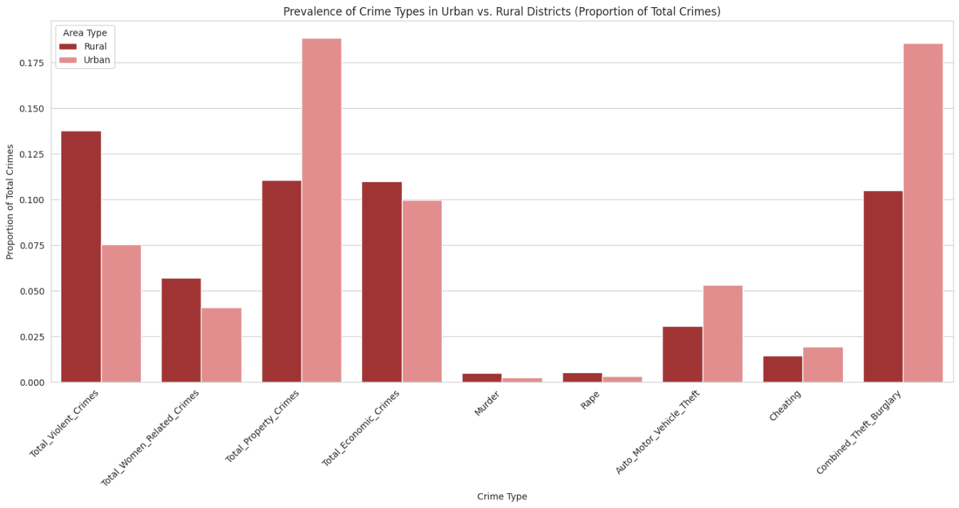
Prevalence of Crime Types in Urban vs Rural Districts: Comparison of crime category proportions between urban and rural regions.

Insights

- Urban areas showed a higher proportion of:
  - Property Crimes
  - Auto Motor Vehicle Theft
  - Combined Theft/Burglary
  - Cheating
- Rural areas showed a higher proportion of:
  - Violent Crimes
  - Women-Related Crimes
  - Economic Crimes
- Murder and rape proportions remained relatively similar across both regions.

Interpretation

The chart indicates that crime patterns vary significantly between urban and rural districts. Urban regions are more associated with property and theft-related crimes due to higher population density and economic activity, while rural regions show relatively higher violent and women-related crime proportions. These differences highlight the importance of region-specific crime prevention and policing strategies.
CHAPTER 9: DASHBOARDS

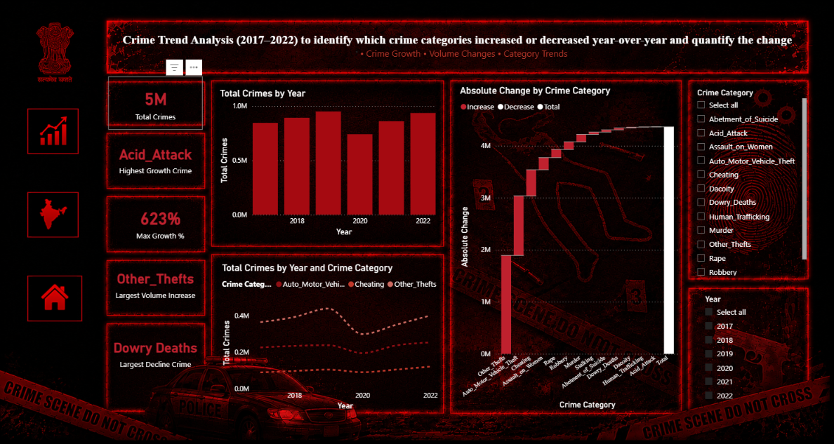
Temporal Crime Trend Analysis Dashboard (2017–2022): Interactive dashboard showing year-wise crime trends, category-wise growth and decline, absolute crime changes, and temporal variations across major crime categories in India.

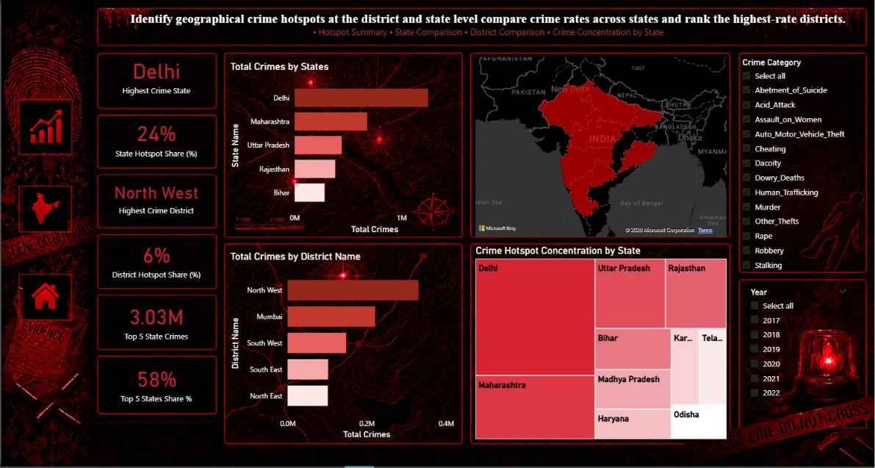
Geographic Crime Hotspot Analysis Dashboard: Interactive dashboard showing state-wise and district-wise crime concentration, hotspot ranking, geographic distribution, and crime share analysis across major crime hotspots in India.
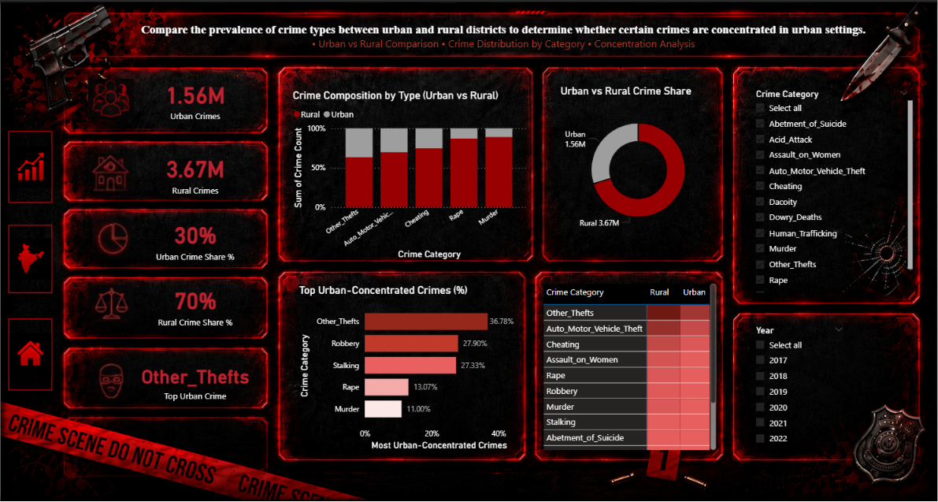
Urban vs Rural Crime Analysis Dashboard: Interactive dashboard comparing urban and rural crime distribution, crime category concentration, crime share percentages, and urban-focused crime patterns across major crime categories in India.

CHAPTER 9: CONCLUSION

This report analyzed district-level crime trends in India from 2017 to 2022 and transformed raw NCRB crime records into a structured analytical framework for meaningful interpretation. The study showed that crime is not evenly distributed across the country; instead, it is concentrated in a few major states and urban districts, with Maharashtra, Uttar Pradesh, Delhi, North West Delhi, and Mumbai emerging as major hotspots. The analysis also confirmed that crime behaviour changes over time, with noticeable disruptions in 2020 and recovery in later years.

The correlation analysis further revealed that major crime groups are strongly interconnected, especially violent crimes, women-related crimes, and serious offenses such as murder, rape, and assault. The urban–rural comparison showed clear differences in crime composition, with urban areas having a higher share of property-related crimes, while rural areas contributed more to overall violent and women-related crime proportions. These findings highlight the importance of region-specific, category-specific, and time-sensitive crime prevention strategies.

Overall, the project demonstrates how descriptive analytics and visualization can uncover hidden crime patterns, identify high-risk regions, and support evidence-based policymaking. The dashboard and report together provide a clear foundation for targeted policing, better resource allocation, and future predictive crime analysis.

CHAPTER 10: FUTURE IMPROVEMENT

- Integrate real-time NCRB or live crime reporting systems for continuous monitoring.
- Include population and census data to calculate per-capita crime rates.
- Add month-wise and seasonal analysis for deeper temporal insights.
- Apply machine learning models for crime prediction and hotspot forecasting.
- Perform geospatial analysis using GIS and heatmap visualization techniques.
- Develop district-level risk scoring and anomaly detection systems.
- Expand the dashboard with real-time filtering and advanced interactive analytics.
- Incorporate socio-economic indicators such as literacy, unemployment, and urbanization for improved crime pattern analysis.
- Improve urban–rural classification using official census-based classifications instead of proxy methods.
- Extend the study to include cybercrime and emerging digital crime categories.

